**Final Practical:** Design and develop a website using recommended design practices, HTML, and CSS.

1. **Concept:** Answer the following questions:

* What is the name and purpose of the site?
  + The Top Ten is the name of the site and its purpose is “supposedly” to provide information about the top ten most influential people in their field each month and for this project I choose to provide information about the top ten most influential people in the Computer Field.
* What do you want the website to accomplish?
  + Teach the user some general information about the Top Ten people in each field.
* What opportunity, problem, or issue is your site addressing?
  + The issue that the site is addressing is the lack of general information about important people.
* Who is your intended audience (Clearly describe in terms of age, gender, interests, socioeconomic criteria, etc.)?
  + Any internet user who is the above the age of 12 and can read.
* What type of content might be included in your site? (The type of text, graphics and media needed for the website)
  + Pictures and text.
* List at least two related or similar sites found on the Web.
  + <https://en.wikipedia.org/wiki/Main_Page>
  + <https://www.britannica.com/>

1. **Design:** Produce a site map of your website.
   1. Sitemap will be found under sitemap.xml

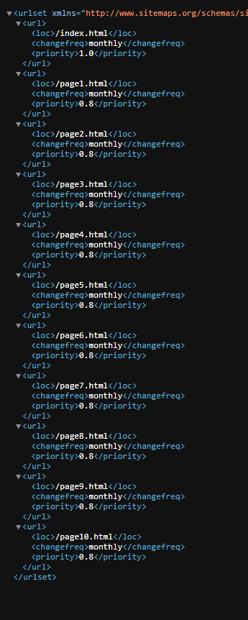

1. **Development:** Your website will contain a home page and at least ten (10) content pages. You are required to create an external style sheet (.css file) that configures text, color, and page layout. (No font tags, but limited use of embedded CSS or inline CSS is allowed.) Create a top-level file folder for your site. All files needed for your site must reside in or below this folder. Please zip-compress this folder when submitting your final exam.

Required components of the pages include:

* Appropriate meta tags
* At least one page utilizing tables effectively to display tabular information
* One or more e-mail hyperlinks
* At least three relevant, external hyperlinks
* At least the home page adjusts to work with a mobile device, e.g., a cell phone
* Consistent banner logo area
* Consistent main navigation
* Association with external style sheet (.css file)
* One Bonus Feature: YouTube video, CSS image gallery, or CSS Transition
* One page containing a form with at least three elements

*(use the demo script* [*http://webdevbasics/script/demo.php*](http://webdevbasics/script/demo.php) *and the post method)*

AT LEAST TWO (2) browsers must render each page similarly. Your website project will be evaluated on the following criteria:

* Including all the required web page elements above.
* Integration of all the website’s pages using the design principles of repetition, contrast, proximity, and alignment.
* Following recommended design practices in Chapter 5 and <http://terrymorris.net/bestpractices>
* The visual appeal of the site to your intended audience